While using deep learning, a model uses more than one epoch since the training since the model accuracy and loss may vary over epochs. In Figure xx, the model is unable to make any meaningful predictions in the beginning. After a few epochs, it fits perfectly fine to the dataset as the training and validation accuracy stagnates and rarely increased at some epochs. Initially, the validation accuracy linearly increased but then becomes constant Since the gap between the training and validation accuracy reduces over time, it implies that that the model has very less indication of overfitting and has given good accuracy results over epochs.

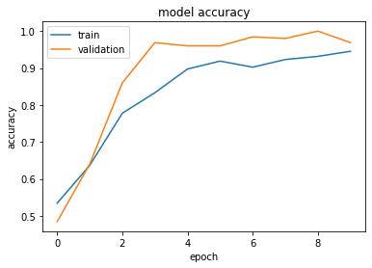

Model loss, on the other hand, indicates how well a model performs after an iteration of optimisation. It is the summation of errors a model has on the training and validation dataset. Looking at Figure xx, it is observed that the model achieves a good learning rate. Similar to the validation accuracy, the validation loss falls linearly initially but after some epochs it stabilises. This indicates that the model has succeeded in memorising the data. Model loss will always be positive.

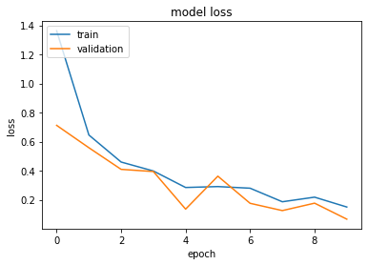

In order to get a summary of the results on a classification problem, a confusion matrix is computed to visually understand the results of the model. It summarises the correct and incorrect predictions broken down by each class. It shows how the classification model gets confused when it makes predictions and gives an insight not only into the magnitude of errors being made but also regarding the type of errors being made.

|  |  |  |
| --- | --- | --- |
|  | COVID-19 | NORMAL |
| COVID-19 | True Positive | False Negative |
| NORMAL | False Positive | True Negative |

True Positive: Observation is positive, the prediction is positive.

False Negative: Observation is positive, the prediction is negative.

False Positive: Observation is negative, the prediction is positive.

True Negative: Observation is negative, the prediction is negative.

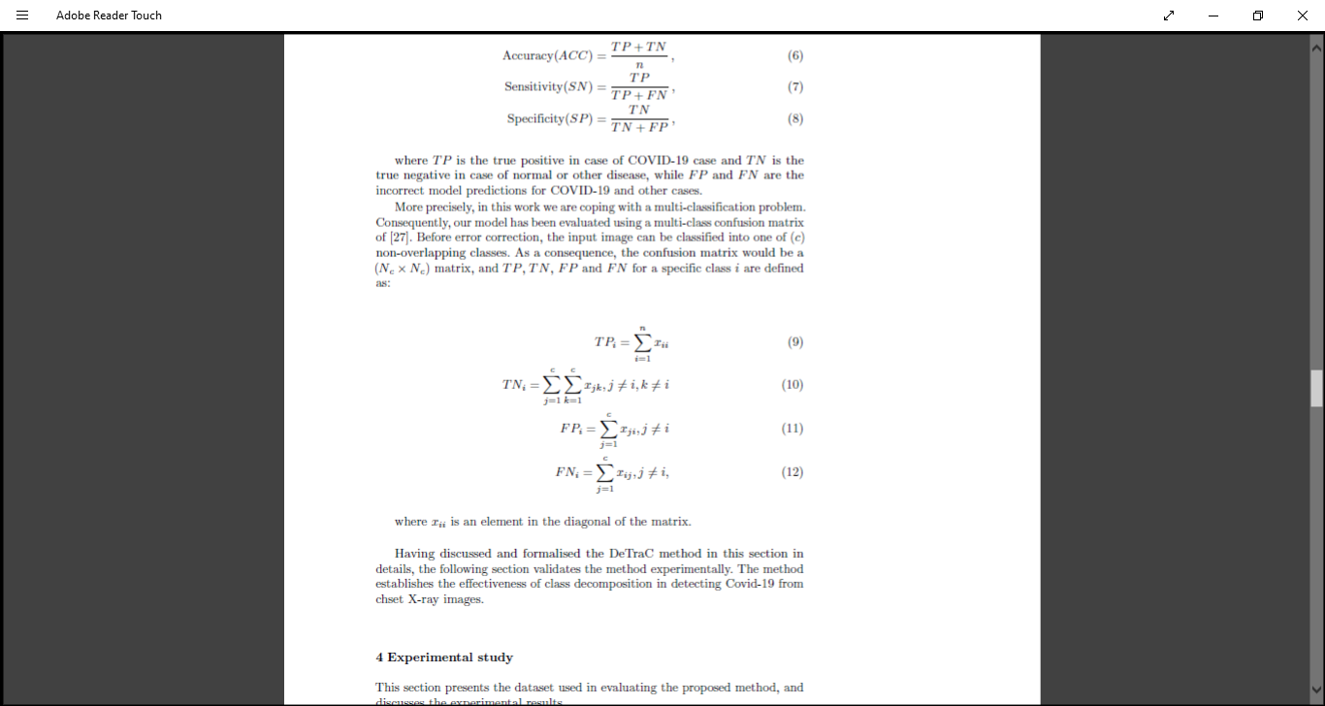

The Accuracy, Misclassification Error, Sensitivity Specificity and Precision of the model are evaluated from the Confusion Matrix to get a deeper understanding about model fitting.

Accuracy: Accuracy is used to measure the magnitude of the correctly predicted classes. It calculates how many COVID-19 and Normal patients have been correctly classified respectively. The formula is given as:

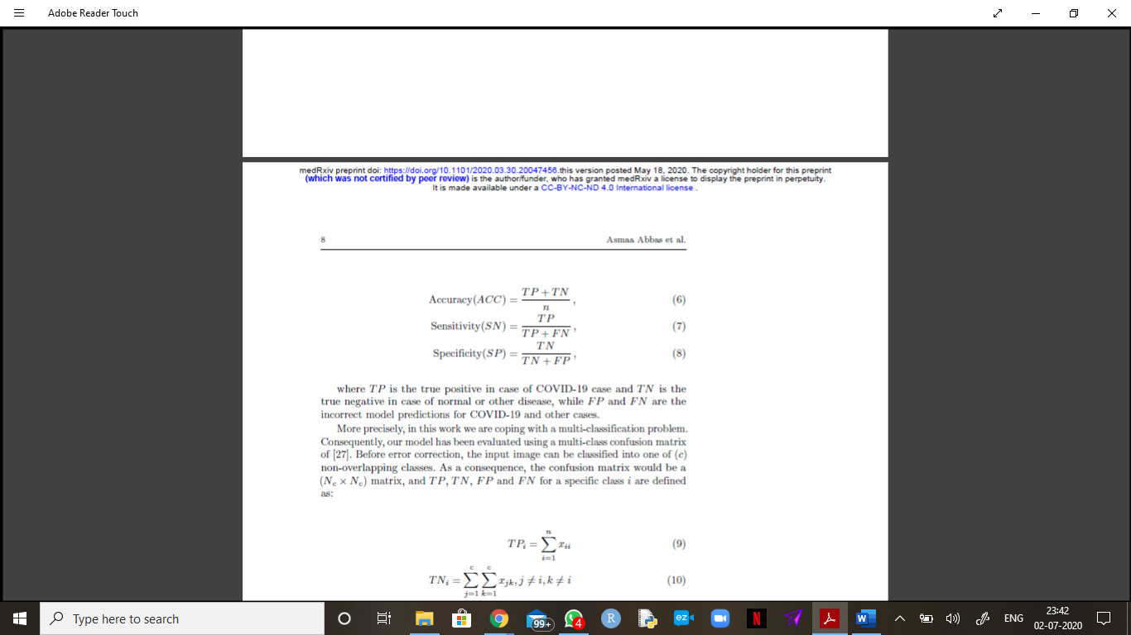

Misclassification Error: Misclassification error is used to measure the magnitude of the wrongly predicted classes. It calculates the amount of COVID-19 and Normal patients who have been wrongly classified respectively. The formula is given as:

1- ACC

Sensitivity: Sensitivity is used to measure how the model is detecting the positive class. It calculates how many COVID-19 patients are correctly predicted. The formula is given as:

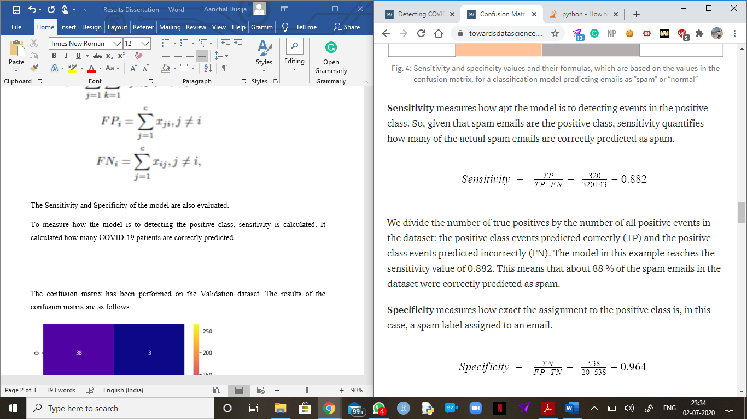

Specificity: Specificity is used to measure how the model is detecting the negative class. It calculates how many Normal patients are correctly predicted. The formula is given as:

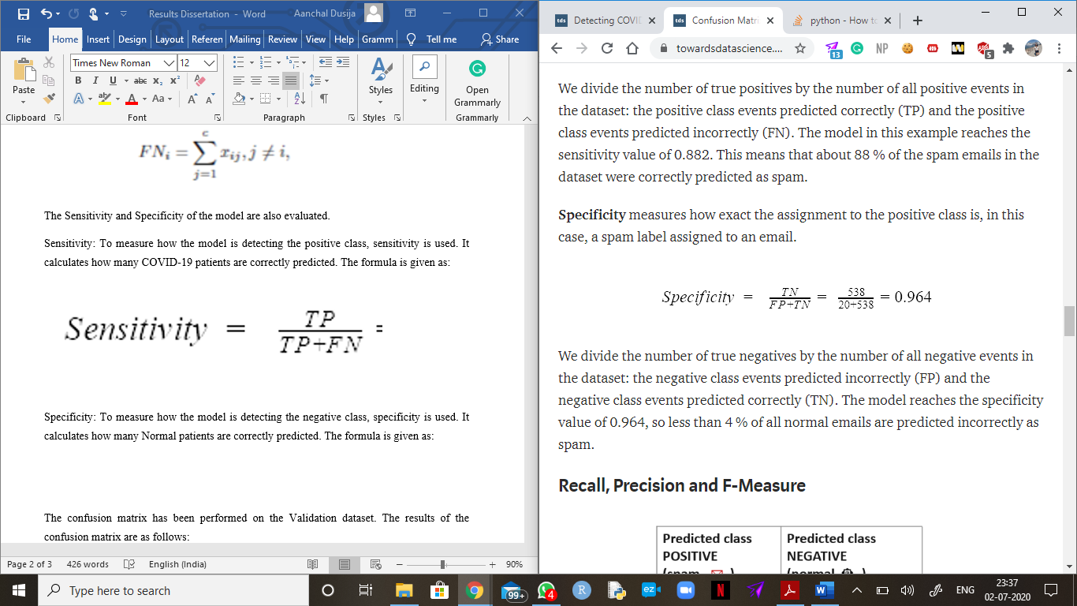

Precision: Precision is used to measure the ability of the model in detection of only the relevant datapoints. It calculates the total number of positives present in the data. The formula is given as:

TP/TP+FP

The confusion matrix has been performed on the Validation dataset. The results of the confusion matrix are as follows:

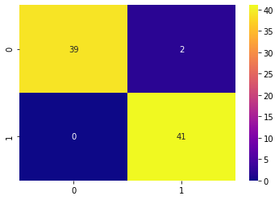

On decoding the Confusion matrix, it is observed that out of 41 COVID-19 affected patients, there are 2 patients wrongly classified and, out of 41 Normal patients, 0 patients have been wrongly classified. In our model, 2 of the patients have been wrongly classified in total.

|  |  |  |  |  |
| --- | --- | --- | --- | --- |
| Accuracy | Misclassification Error | Sensitivity | Specificity | Precision |
| 0.9756 | 0.0243 | 0.9512 | 1.000 | 1.000 |

On evaluating the model, it is observed that the validation accuracy is approximately 97%. Although, it is a good accuracy score, there may be some cons to deploy this model since there could be some major consequences. For example, with a 97% accuracy, the model would be able to rightly detect 97 patients out of 100 but would wrongly guess 3 patients. There can be a scenario where a patient can be misclassified, that is, a patient can be COVID-19 negative but the model states that he is COVID-19 positive. Hence, he will made to quarantined with patients who are COVID-19 positive leading to him getting affected. On the other hand, it may also happen that a patient can be COVID-19 positive but the model states that he is COVID-19 negative. This could be dangerous as he could spread the virus to other people in his surroundings. Thus, when it comes to medical imaging, one must be super cautious and must ought to have a good accuracy score as it is a question of human life.